Build a Serverless Web Application

Lab Overview

In this lab you will build a fully serverless application which will include the following services:

|  |  |
| --- | --- |
| -  -  -  -  - | Amazon SQS  AWS Lambda  Amazon DynamoDB  Amazon S3  Amazon API Gateway |

The application uses a static website hosted in Amazon S3 that connects to an Amazon API

Gateway. The website allows shop owners to manually submit product purchase information to the

DynamoDB Table.

When data is entered into the webform running on S3, the API triggers an AWS Lambda function to

place the data as a message in an SQS queue.

Another Lambda function is then triggered and processes the message in the queue and adds the

data to the DynamoDB table.

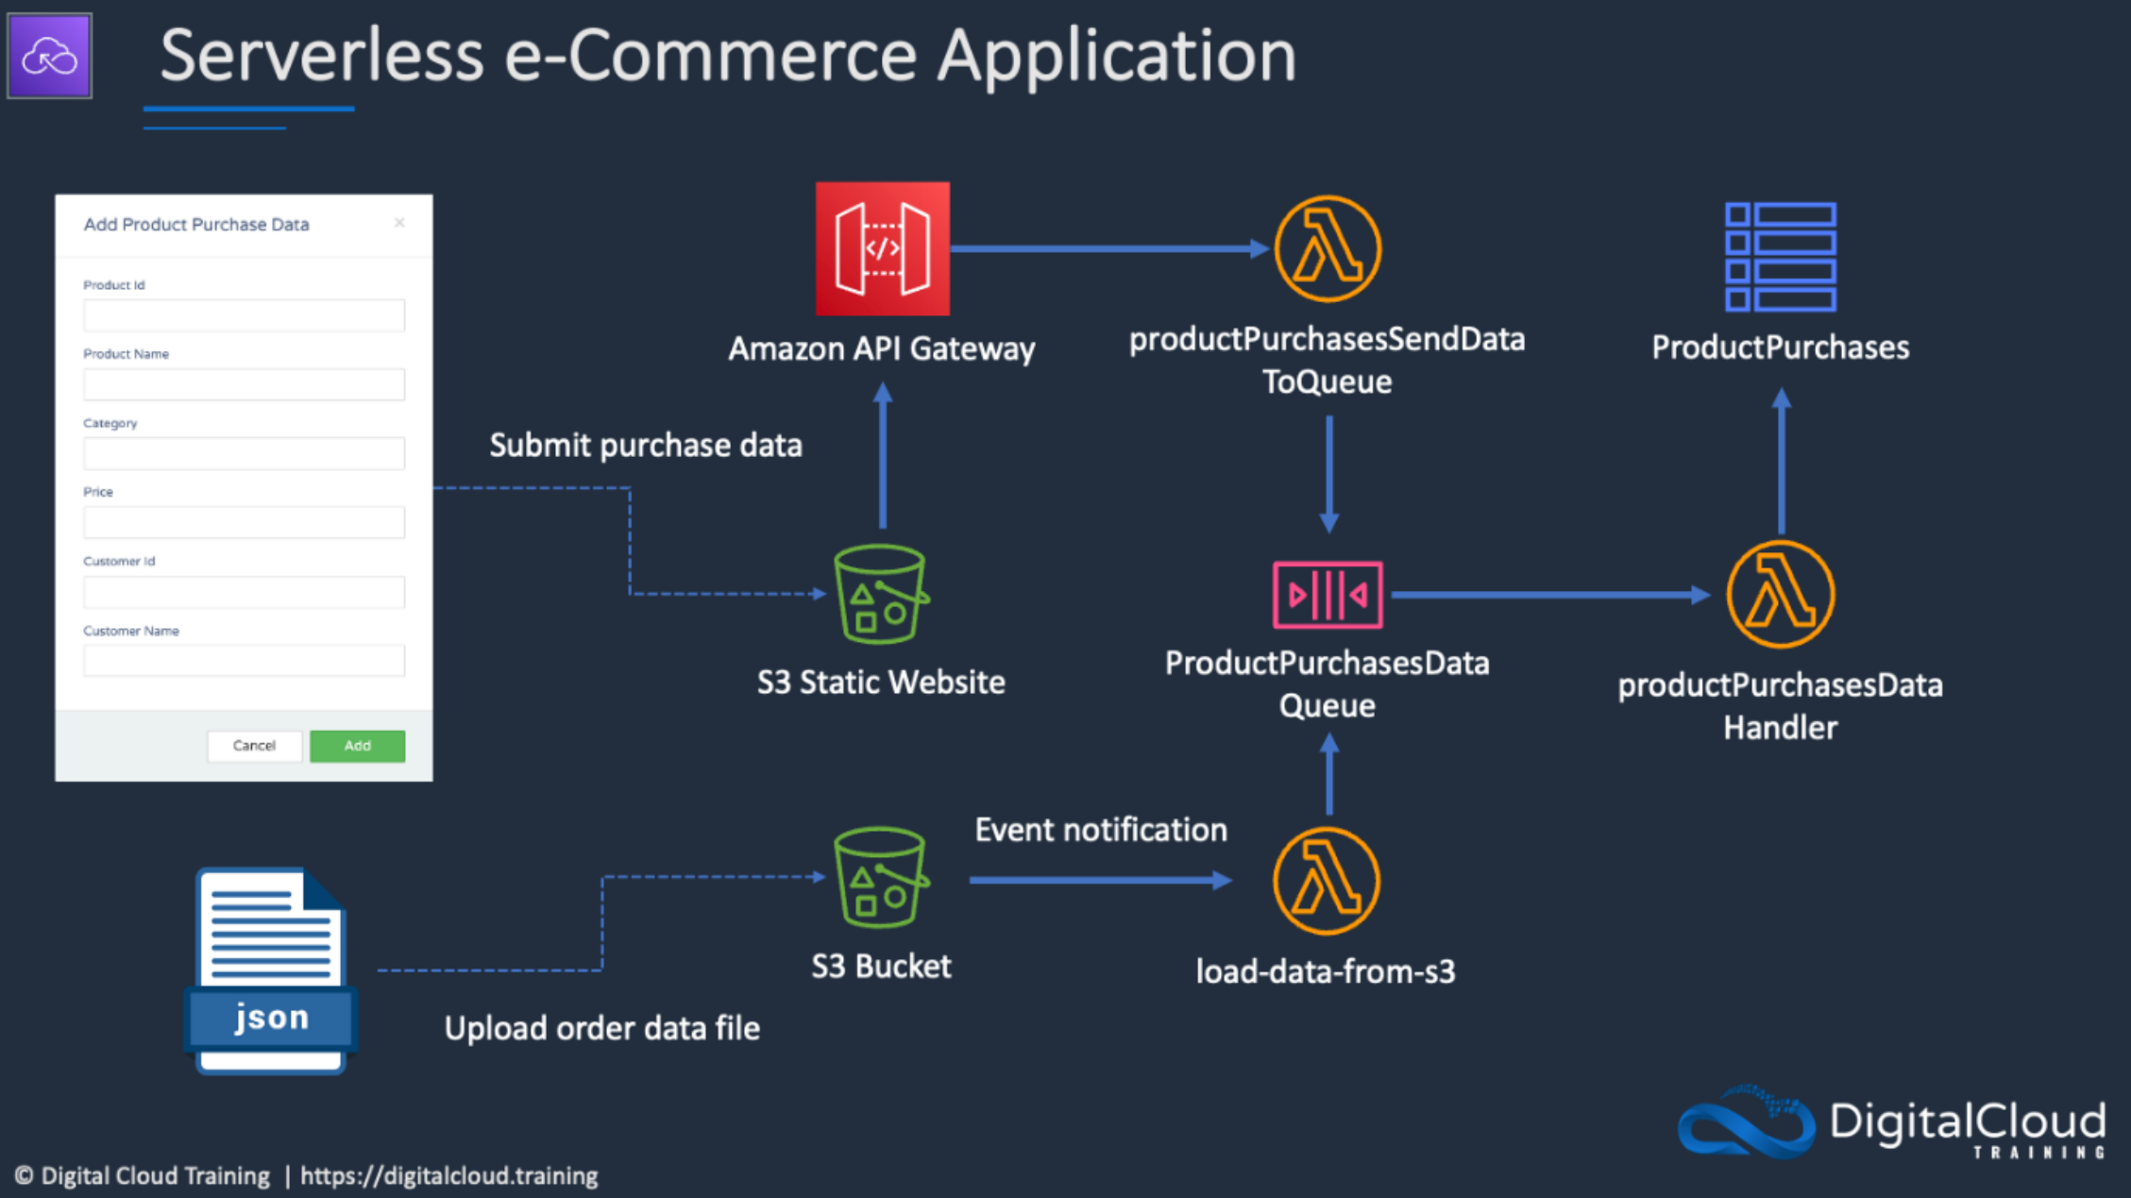The image below depicts the solution architecture:

Requirements (Prerequisites)

● ***AWS Free Tier Account***

● ***The AWS CLI or AWS CloudShell***

Resources

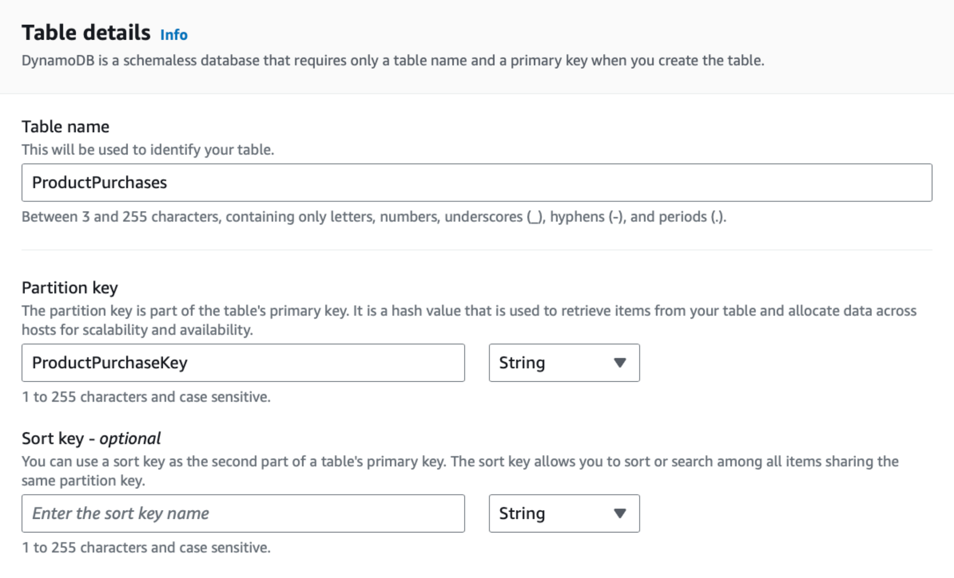

Please download the lab resources zip file [here.](https://cloud-mastery-bootcamp.s3.amazonaws.com/lab-guides/solutions-architecture/build-a-serverless-app.zip)

Exercise Overview

**Exercise 1** - Create the DynamoDB Table

**Exercise 2** - Create the SQS Queue

**Exercise 3** - Create the Function for Adding Data to DynamoDB

**Exercise 4** - Test Adding Data to Queue

**Exercise 5** - Create the Function for Adding Orders to the Queue

**Exercise 6** - Create the API

**Exercise 7** - Create the Static Website, and Test the application

Exercise 1 - Create the DynamoDB Table

Task 1 – Create the DynamoDB Table

First we will create the DynamoDB table which will store the transactions

made from the front end.

1. Head over to the DynamoDB console and click on Create Table.

2. Call the table ‘ProductPurchases’ and enter ‘ProductPurchaseKey’ for

the partition key.

3. Scroll down and click ‘Create Table.’

engrmohiuddin4@gmail.com



Exercise 2 - Create the SQS Queue

Task 1 – Create the SQS Queue

First we will create the SQS Queue which will store the messages from the

front end.

1. Head over to the SQS console, and click on Create Queue

2. Leave the queue as a Standard Queue and call it

‘ProductPurchasesDataQueue’.

3. We don’t need to make any more changes other than scrolling down

and clicking ‘Create Queue’.

4. Take note of the URL which you can see on the next screen by saving

it in a notepad document.

Exercise 3 - Create the Function for Adding Data to DynamoDB

Task 1 – Create the IAM Role

Next, we will create the Lambda execution role.

1. Head over to the IAM console and click on Create policy.

2. Under the JSON tab find and copy contents of ‘lambda-policy-for-sqs-

ddb.json’ into the JSON field, ensuring you replace your account

number.

3. Click ‘Create Policy’ after calling the permissions policy

"pushPurchasesToQueue".

4. We then need to attach this policy to a role. Select Roles in the IAM

console and click ‘Create Role’.

5. Under ‘Use Case’ select Lambda and click next.

6. Filter the permissions policy by typing in the name of the policy we just

created (‘pushPurchasesToQueue’) attach it and click next.

7. We will then call the role ‘pushPurchasesToQueue’ and click ‘Create

Role.

Task 2 – Create the first Lambda Function

Next, we will create the first Lambda function which processes messages from

the queue and places the order entries into the DynamoDB table.

1. Head over to the Lambda console and click on Create Function.

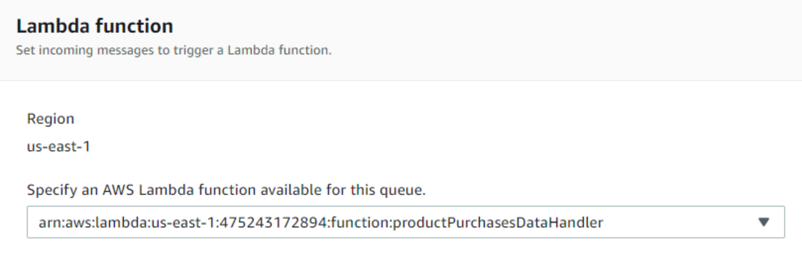

2. We will call the Lambda function ‘productPurchasesDataHandler’ and

change the runtime to ‘Python 3.12’.

3. Click on ‘Change Default Execution Role and click ‘Use and Existing

Role’ and use the ‘pushPurchasesToQueue’ we selected earlier.

4. Click ‘Create Function’.

5. Now we can add the code. Under ‘Code’ copy and paste the contents

of the main.py file from the Part 1 folder in the downloads in your code

window in the lambda console.

Task 3 – Configure the SQS Queue

First we will configure the SQS Queue which triggers the Lambda function we

just created.

1. Head back over to SQS and click on the

‘ProductPurchasesDataQueue’ Queue.

2. Click ‘Lambda Triggers’ and ‘Configure a Lambda Trigger’.

3. Select the lambda function we just created and click save.

Exercise 4 – Test Adding Data to Queue

Task 1 – Run the Test Code

We will run AWS CLI commands to test that messages placed in the queue

are properly processed by Lambda and added to the DynamoDB table.

1. Open AWS CloudShell and upload and extract the zip file download.

You can also use the wget command with the S3 download URL.

2. Unzip the download and change to the Part-1 folder in which the

‘message-body-1.json’ file is (build-a-serverless-app\Part-1).

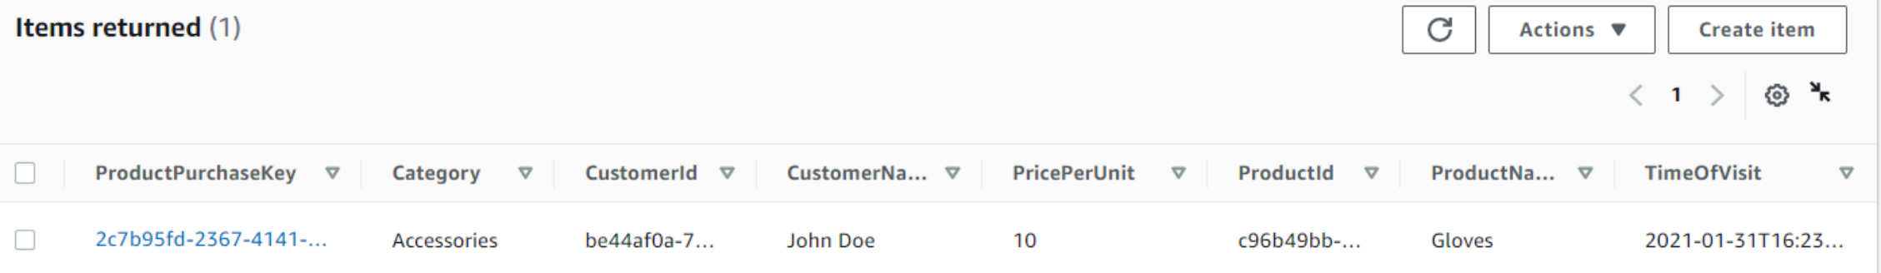

3. Modify the queue URL for the command in the instructions.md file.

Then run the command.

aws sqs send-message --queue-url **YOUR-QUEUE-URL**

--message-body file://message-body-1.json

If this works, we should see Lambda has written items to the

DynamoDB Table which will correspond to the JSON file of whichever

message-body you have chosen. Feel free to run this command with

all 5 message bodies to see them populate the DynamoDB table.

Exercise 5 – Create the Function for Adding Orders to the

Queue

Task 1 – Create the IAM Role

Next, we will create the second Lambda execution role.

1. Head over to the IAM console and click on Create policy.

2. Copy the contents of the "lambda-policy.json" file (from the Part-2

folder) into the JSON field, ensuring you replace your account number.

3. Click ‘Create Policy after calling the permissions policy

‘productPurchasesSendMessage’.

4. We then need to attach this policy to a role. Select Roles in the IAM

console and click ‘Create Role’.

5. Under ‘Use Case’ select Lambda and click next.

6. Filter the permissions policy by typing in the name of the policy we just

created (‘productPurchasesSendMessage’) attach it and click next.

7. We will then call the role ‘productPurchasesSendMessage’ and click

‘Create Role.

Task 2 – Create the Second Lambda function



We will now create another Lambda function. This function will receive order

information from the frontend API and then place the order information into the

queue for subsequent processing.

1. Navigate to the Part-2/DCTProductPurchaseForm\backend folder and

edit the main.py file.

2. Update the queue URL in the main.py with your SQS queue URL and

save the file (you should only need to change the account ID).

3. Create an AWS Lambda function and call it

‘productPurchasesSendDataToQueue’, select the Python 3.12

runtime.

4. Select the ‘productPurchasesSendMessage’ which we created earlier

for the Lambda execution role.

5. Click ‘Create Function.

6. Copy the code from the edited main.py into the code editor and deploy

the changes.

Exercise 6 – Create the API

Task 1 – Create the REST API.

We will now create the REST API.

1. Head to the API Gateway console, and click Build under the REST API

– do not click the Private option, make sure you build this one:

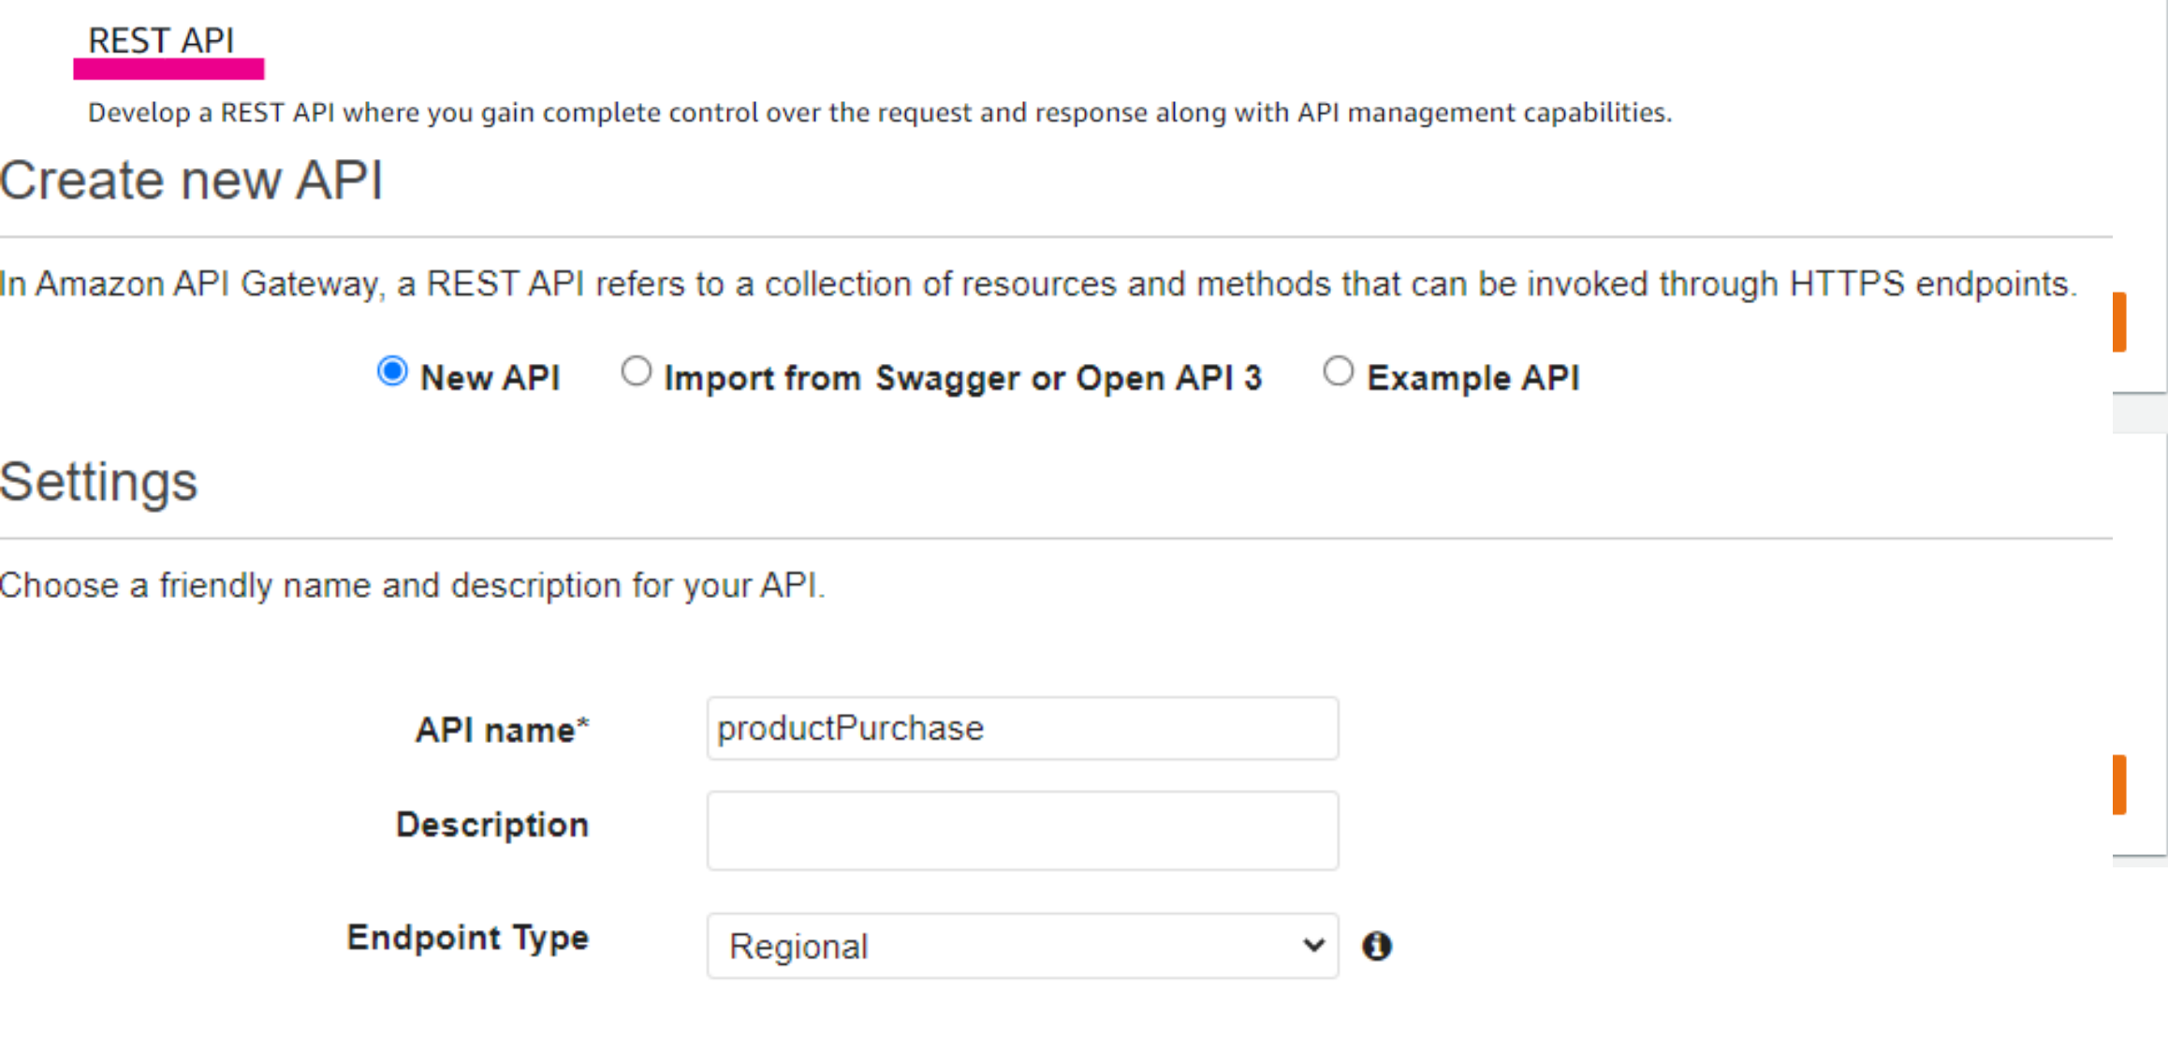

2. Select ‘New API’ and call it ‘productPurchase’.

3. Click ‘create resource’ and call the resource ‘productpurchase’ and

ensure the resource path is /productpurchase.

4. Enable Cross Origin Resource Sharing (CORS) and click ‘Create

Resource’.

5. Click ‘Create Method’ and select ‘PUT’ from the dropdown.

6. Enable a Lambda Proxy integration and select the

‘productPurchasesSendDataToQueue’ Lambda function.

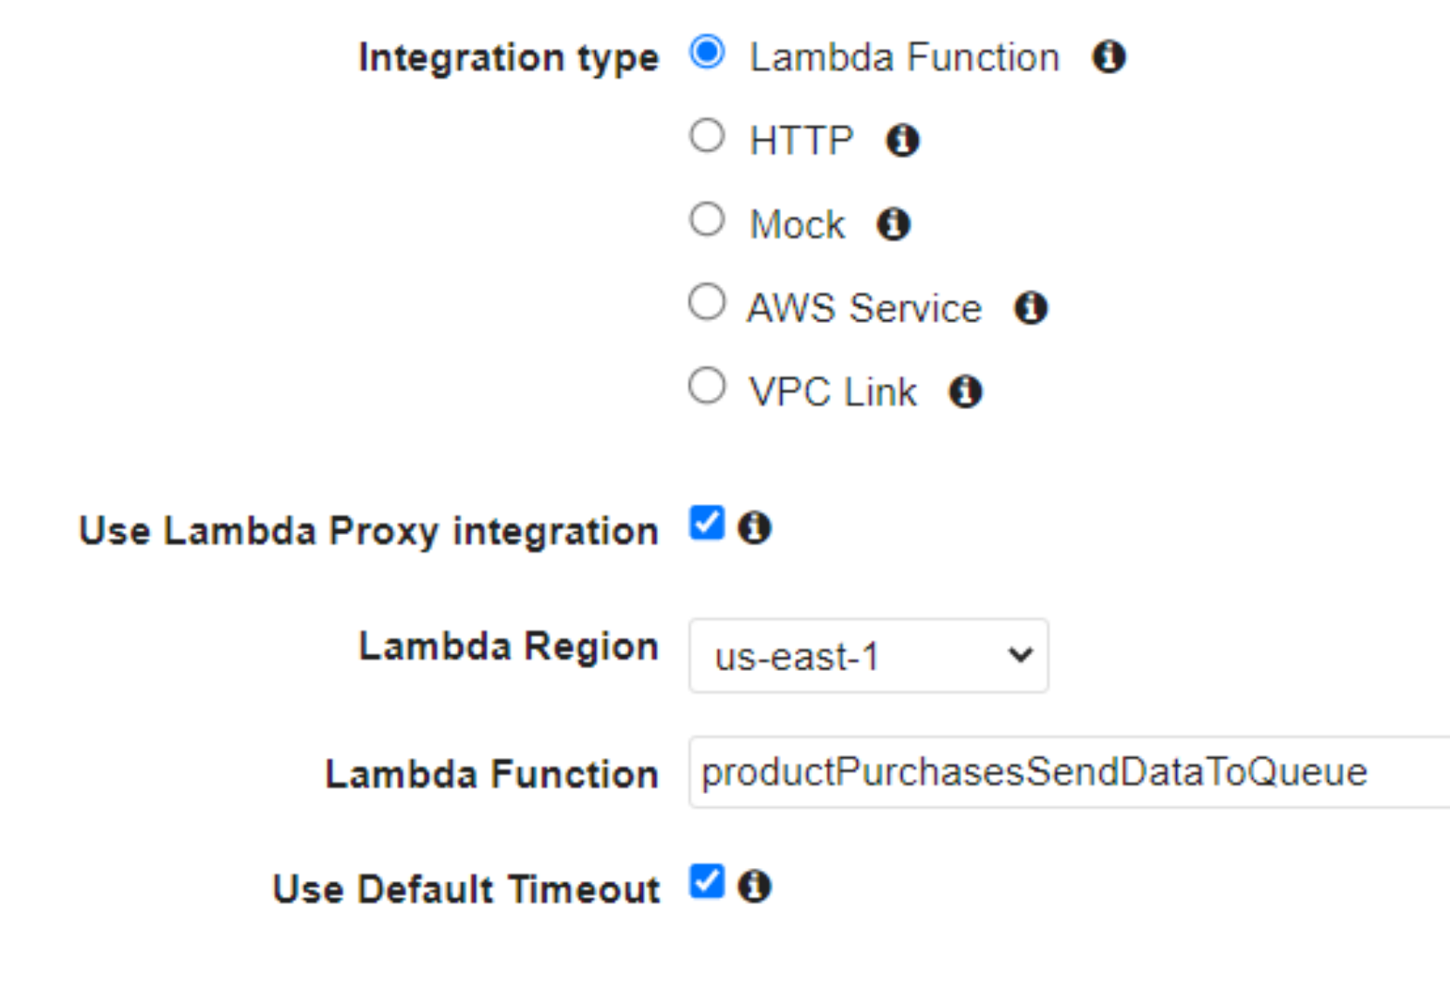

Click “Create Method”.

7. Under Actions click ‘Deploy API’ – and choose ‘new stage’ and call the

stage ‘dev’. Click Deploy.

8. Next, copy the API endpoint (e.g. https://jtsvxqdt3k.execute-api.us-

east-1.amazonaws.com/dev) and paste it on line 125 in the index.html

in the ‘DCTProductPurchaseForm/frontend’ directory.

9. Make sure you keep the /productpurchase after /dev like this:

Exercise 7 - Create the Static Website and test the application

Task 1 – Create the S3 Bucket.

We will now create the S3 bucket which will host the code for the static

website.

1. Head over to the S3 console and click ‘Create Bucket’.

2. Call the bucket ‘product-purchases-webform-XXXX with the Xs

numbers representing a random string of letters or numbers, so it

remains globally unique.

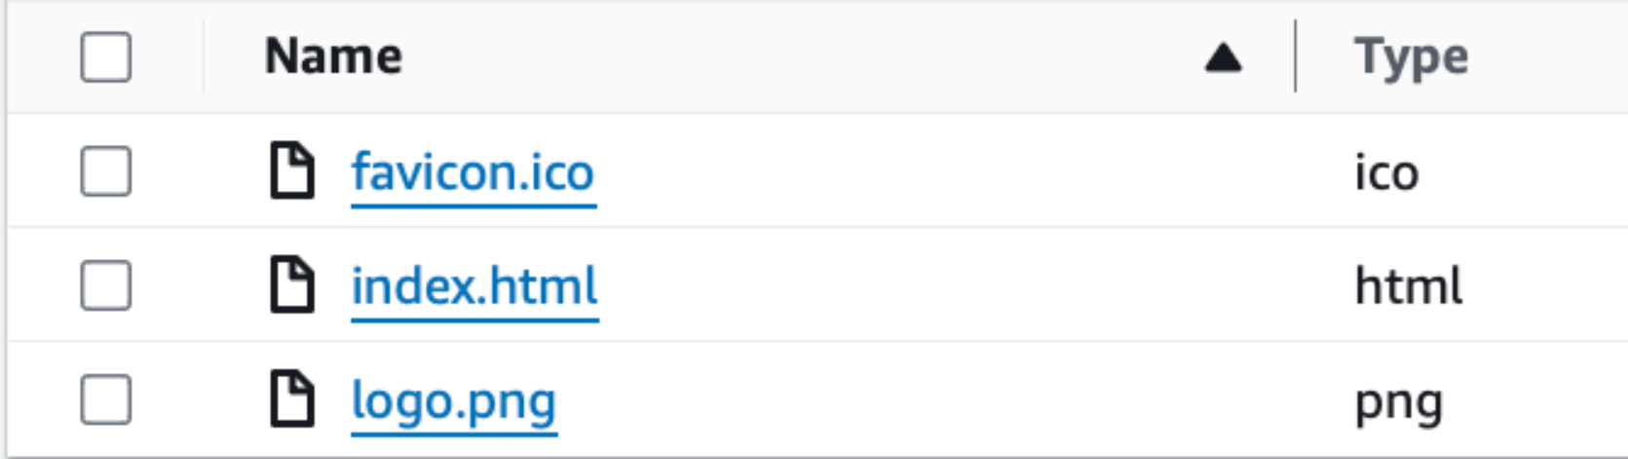

3. Disable and acknowledge blocking all public access and click ‘Create

Bucket’.

4. Once the bucket is created, go to the properties tab, and enable static

website hosting, and type ‘index.html’ for the index document.

5. Go to the Permissions section and add the permissions statements

from the ‘frontend-bucket-policy.json’ file. Make sure to change the

name of the bucket and save changes.

6. We will next upload the frontend code using CloudShell.

7. Using your terminal/command prompt, navigate to the

‘DCTProductPurchaseForm/frontend’ directory.

8. From the frontend directory, run the command, to copy the files to S3

(with your bucket name specified).

aws s3 sync ./ s3://product-purchases-webform-

9. You should see a series of commands running which show all the

frontend contents being uploaded.

10. If we check the S3 bucket – there should be the code for the website!

11. Click on the index.html document and copy the object URL and paste

it into the browser.

12. Alternatively, you can use the static website endpoint (HTTP only).

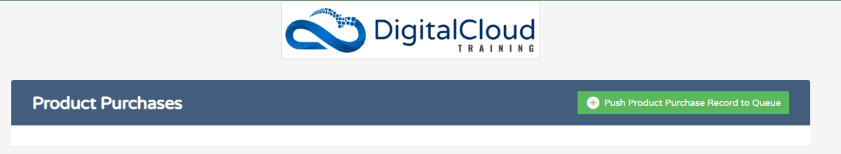

The following website should load:

13. Click ‘push product visit record to queue’ and enter some information,

like this, and click ‘Add’.

14. It should have appeared in the DynamoDB table!

Thanks for taking part!